

Service Acceptance Form

YXTENSYS

MVNO SERVICE

Version 0



Document Revisions

|  |  |  |  |  |
| --- | --- | --- | --- | --- |
| Version | Date | Description | Author(s) | Validate |
| 1.0 | 01 10 2019 | First edition of the document | TSL PMO |  |

Table of Contents

1 PURPOSE 1

2 Delivered Services and items 2

2.1 Access to Transatel Web Portal 2

2.2 Access to Transatel sFTP servers 2

2.3 Provisioning and SIM Lifecycle 2

2.4 SIM card s / Profiles 3

2.5 Voice, SMS, Data Services 3

2.6 Reports and CDR 4

2.7 Voicemail 4

3 Service acceptance 5

3.1 List of reserves: 2

3.2 List of issues: 3

# PURPOSE

The purpose of this document is to sign off the services delivered by Transatel to the Customer. It verifies what deliverables are turned over to the customer and that the customer has accepted / approved those deliverables.

This form would be completed during the customer acceptance milestone in the closing phase of the MVNO project.

# Delivered Services and items

## Access to Transatel Web Portal

|  |  |  |  |  |
| --- | --- | --- | --- | --- |
|  | OK | OK with reserves | NOK | Comments |
| Connection to Auriga interface (login/password) | OK |  |  |  |

## Access to Transatel sFTP servers

|  |  |  |  |  |
| --- | --- | --- | --- | --- |
|  | OK | OK with reserves | NOK | Comments |
| Connection to the sFTP account (login/password) | OK |  |  |  |
| Correct file path within the sFTP server | OK |  |  |  |

## Provisioning and SIM Lifecycle

All tests should be done with an Activated SIM cards or Subscription.

|  |  |  |  |  |
| --- | --- | --- | --- | --- |
|  | OK | OK with reserves | NOK | Comments |
| Tests sim are available | OK |  |  |  |
| SIM card Activation | Ok |  |  |  |
| SIM card Suspension | Ok |  |  |  |
| SIM card Reactivation | Ok |  |  |  |
| SIM Swap | OK |  |  |  |
| SIM card Modification (incl. Ports) | OK |  |  |  |
| SIM card Termination | OK |  |  | NB from TSL : this action deactivates the SIM definitely |

## SIM card s / Profiles

|  |  |  |  |  |
| --- | --- | --- | --- | --- |
|  | OK | OK with reserves | NOK | Comments |
| Requested PIN code is set | OK |  |  | Note from Transatel : 0000 |
| Display of the Customer name on device | OK |  |  | Note from Transatel : MyTS |
| Call to the Customer Care centre using the dedicated shortcode | OK |  |  | Note from Transatel : 7491 |
| Call to voicemail using the dedicated shortcode | OK |  |  | Note from Transatel : 898 |

## Voice, SMS, Data Services

|  |  |  |  |  |
| --- | --- | --- | --- | --- |
|  | OK | OK with reserves | NOK | Comments |
| Outgoing call | OK |  |  |  |
| Incoming call | OK |  |  |  |
| Outgoing SMS | OK |  |  |  |
| Incoming SMS | OK |  |  |  |
| MMS | OK |  |  |  |
| Data communication 2G |  |  |  |  |
| Data communication 3G |  |  |  |  |
| Data communication 4G |  |  |  |  |
| International roaming | OK |  |  | Optional |

## Reports and CDR

|  |  |  |  |  |
| --- | --- | --- | --- | --- |
|  | OK | OK with reserves | NOK | Comments |
| Rated CDRs delivery | OK |  |  |  |
| Subscriber and Services Report delivery |  |  | NOK | Pas de fichier sim |
| High Usage alerts and/or suspensions are active | OK |  |  | Optional |

## Voicemail

|  |  |  |  |  |
| --- | --- | --- | --- | --- |
|  | OK | OK with reserves | NOK | Comments |
| Message left on the voicemail | OK |  |  |  |
| SMS Notification of new message received by the handset | OK |  |  |  |
| Voicemail message consultation | OK |  |  |  |

# Service acceptance

Name of the Customer:

|  |
| --- |
| YXTENSYS |

Customer Contact:

|  |  |
| --- | --- |
| First Name | Stéphane |
| Last Name | Touzot |
| Position | PDG |

SIM card serial numbers (ICCID) used for validation:

|  |
| --- |
| 1930881823659 |
| 1930881823667 |
| 1930881823675 |
| 1930881823683 |
| …/… |

I hereby [FirstName, LastName];

[Accept] that the project outcomes and deliverables provided by Transatel work as expected and [Customer Name] is ready to proceed to the next phase: Commercial Launch.

|  |  |
| --- | --- |
| Name | Date and signature |
|  |  |

Please kindly sign this document and send it by email to your project contact.

## List of reserves:

## List of issues:

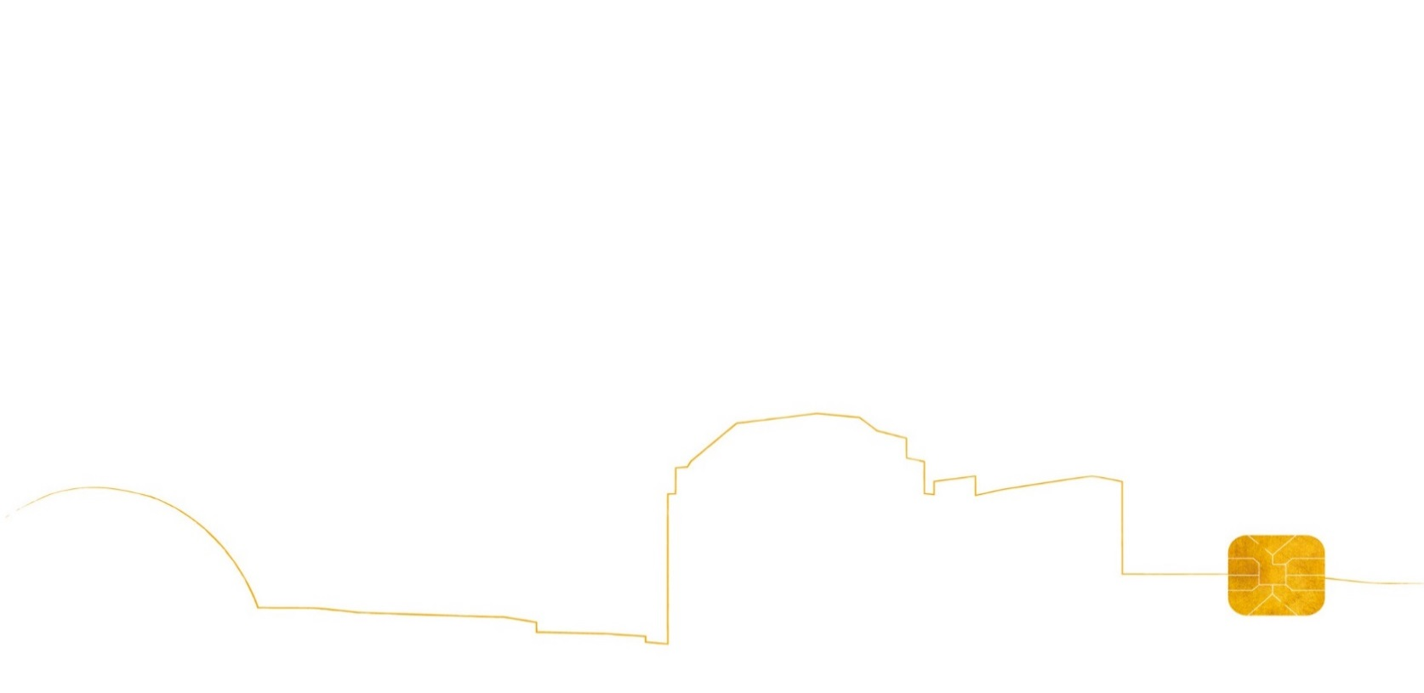



49-51 Quai de Dion Bouton   
CS 50034  
92806 Puteaux Cedex