Yxtensys -Transatel

Operational Manual

Version 2.0



About This Document

Based on the contract signed by Yxtensys and Transatel (“TSL”) , this document outlines the operational processes between the two parties under the MVNA-TSL framework.

This document is only an operational agreement: master document remains contract signed-off by Yxtensys and Transatel.

Owner of this Operational Manual is Transatel.

Transatel oversees any required update (e.g. contact details).

Any request to alter or amend the contents of this document should be raised to Transatel Service Manager and discussed at the regular Service Review Meetings.

Should a new version of this Operational Manual be created, it will be shared by Transatel to Informatique Assistance Fr.

Table of Contents

1 Overall Organization & contacts 1

1.1 The Ops Teams 1

1.1.1 Level 2 Support 1

1.1.2 Level 3 support 1

1.1.3 Client Services Management (CSM) 2

1.2 TSL internal organization and associated scope/responsibility split 2

1.3 MVNO internal organization and associated scope/responsibility split 3

1.4 Business days/hours : Definition 3

2 Incident management 5

2.1 Workflow and legends 5

2.2 Your interface - Service Desk: how does it look like? 6

2.3 Incident ticket format and pre-requisite 7

2.4 Incidents categories – priorities definition or criticality? 8

2.5 Incident 8

2.6 escalation matrix 9

3 Back-OFFICE REQUESTS 10

3.1 Description and process 10

4 Change Management (maintenance & releases) 11

4.1 Description – workflow 11

4.2 notification template 13

5 Change request process 14

6 seRvice review meetings & mvnos follow-up 15

6.1 reporting 15

# Overall Organization & contacts

## The Ops Teams

### Level 2 Support

Yxtensys oversees the Level 1 support diagnosis for an issue raised by the end-customer. Whenever this Level 1 investigation doesn't allow the issue to be fixed, a ticket (encompassing all the needed information described in the "2.3 Incident Ticket Format and Pre-requisite" section below) must then be created on Transatel ticketing system.

The Transatel Support level 2 acknowledge the ticket and starts first investigations.

The team is responsible for:

* Sending the first response
* Setting the right criticality
* Starting the first diagnosis
* Escalating to support level 3 (if needed)
* Giving feedback and communication on the overall investigation
* Closing the ticket and explaining the root cause

### Level 3 support

If the ticket requires higher expertise, it will then be escalated to level 3.

The team is responsible for:

* Monitoring: setup and supervising
* New offers configuration and overall configuration changes (through a Change ticket)
* Incident resolution and back-office requests treatment
* Projects on production environment
* The deployments of releases on production environment
* Post-release checks on production environment
* Overall stability of Services on production environment

### Client Services Management (CSM)

The CSM team provides general support to the Service Provider and is available to answer questions which may arise. It is a not a technical support team, but a first point of escalation, if required. The CSM is the main point of contact for the configuration of added services.

* Point of contact for any operational and technical questions
* First level of escalation if SLAs are not met
* The CSM is responsible for:
  + The overall quality of services provided to the MVNO
  + Providing Post incident reports after critical incidents
  + Coordinating new services implementation between the MVNO and TSL
  + MVNO team training
  + Providing support during changes
  + Identifying service gaps and implementing ways of improvement
  + Generating monthly KPI reports showing all the past month events and the actual performance (network and Incident management) results compared to the agreed SLAs
  + Leading the monthly service review meetings (calls or face to face) where are mentioned:
    - MVNO’s activity
    - The KPI report
    - The future changes
    - AOB if required

## TSL internal organization and associated scope/responsibility split

|  |  |
| --- | --- |
| TSL contact | Contact details |
| Service Manager | Rodrigue Hoton  + 33 (0) 1 74 95 74 75  +33 (0) 6 44 50 92 27  Servicemanagement.fr@transatel.com |
| Product Manager MVNA | Max Graveline  +33 (1) 74 95 74 00  Max.graveline@transatel.com |
|  |  |

## MVNO internal organization and associated scope/responsibility split

|  |  |
| --- | --- |
| MVNO contact | Contact details |
| Commercial contact |  |
| Operational contact |  |
| Support Teams contact |  |

## Business days/hours : Definition

Transatel business hours are defined as follows: from 9.30 am to 6.30 pm CET, Monday to Friday, except French bank holidays. The tickets are treated from 8.30 am to 10.00 pm CET, Monday to Friday.

Fixed Public Holidays in France (the following are held on the same day each year):

* New Year's Day - 1st January each year
* Labour Day - 1st May each year
* VE Day - 8th May each year
* Bastille Day - 14th July each year
* Assumption Day - 15th August each year
* All Saints Day - 1st November each year
* Armistice Day - 11th November each year
* Christmas Day - 25th December each year

Changeable Public Holidays in France (the following are held on different days each year):

* Easter Monday: 4 April 2021
* Assumption Day (40 days after Easter Sunday, always on a Thursday): 13 May 2021

# Incident management

## Workflow and legends

1st case scenario - Incident ticket opened by Yxtensys :

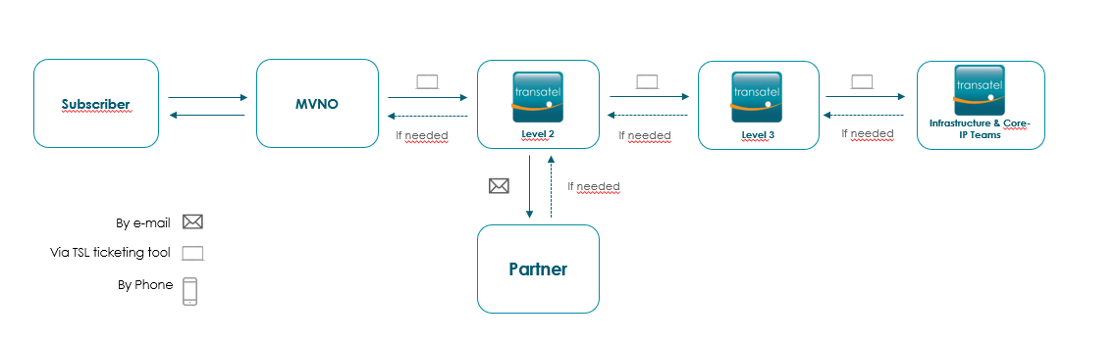

2nd case scenario - Incident notified by Transatel:

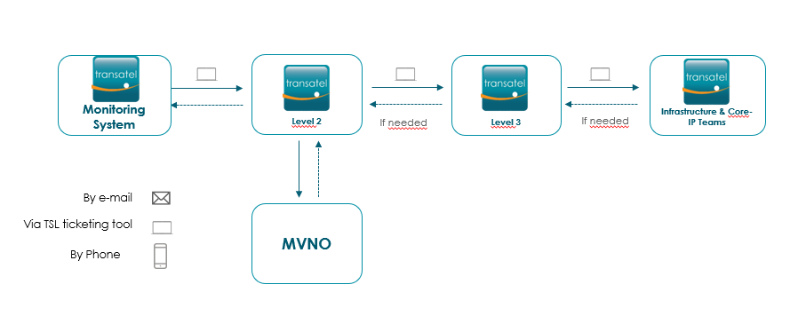

## Your interface - Service Desk: how does it look like?

In order to create an incident ticket, you log into Service Desk and use one of the 3 following choices (the “Operational change” section will not be in your scope):

* Connectivity and networks
* Subs Management
* Wholesales Services

This is described in the screenshot below:

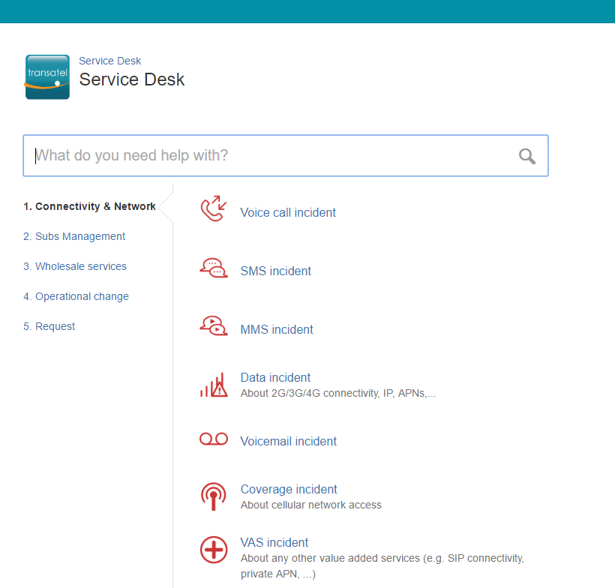

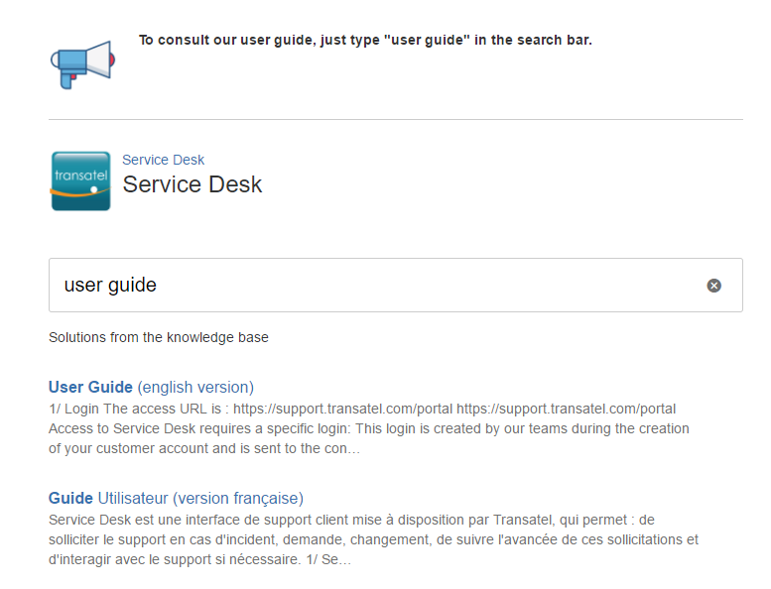You can also find more details about Service desk by downloading the user guide:

## Incident ticket format and pre-requisite

Once you have chosen the incident category (for instance: Connectivity and Network -> Data incident), the ticket creation form will define the information needed. It is very important that all the mentioned fields are filled in, especially with the following details:

* MSISDN (by using the international format)
* ICCID (or Transatel ID)
* Timestamps…

## Incidents categories – priorities definition or criticality?

|  |  |  |
| --- | --- | --- |
| Priority | Description | Identified impact |
| P1 | Major Service Affecting | Faults or incidents significantly affecting the availability or the resilience of a service and/or having an impact on 50% or more of the users of the service. |
| P2 | Intermittently Major Service Affecting | Faults or incidents which affect service on an intermittent basis and/or having an impact on less than 50% of the users of the service and/or materially affecting the MVNO business. |
| P3 | Minor Service Affecting | Faults or incidents producing a minor impact on the service and/or having an impact on individual users. Problem specific to a non-core service (core services being defined as: voice, SMS, data, web access, top-up and activation) or uncommon scenario. |
| P4 | Non-Service Affecting | Faults or incidents producing no impact to the service or a non-conformance to the functional specification. Problems affecting the operation and maintenance of the system, but not directly affecting any user. |

## Incident

There is the possibility to request a post-incident report for Critical incidents, the communication workflow can be found below:

|  |  |  |  |  |
| --- | --- | --- | --- | --- |
| Criticality | Root cause details – default | Root cause details – investigation | MVNO contact | TSL contact |
| Critical | TSL incident management team will endeavour to provide root cause description within conclusion email (i.e. at last when incident is closed). | Should more details be required, ad-hoc exchanges can occur between TSL and MVNO.  TSL Incident Management will provide a PIR (Post-Incident Report) within a week after resolution |  | Client Service Manager |
| Should more details be required, updates would be exchanged during monthly SRM. | Rodrigue Hoton | Service Manager |

## escalation matrix

|  |  |  |
| --- | --- | --- |
| Level | Transatel Contact | Contact details |
| TSL Level 1 | Support Level 2 | During working hours: [incident@support.transatel.com](mailto:incident@support.transatel.com)  +33 (0) 1 74 95 95 09 can be reached |
| TSL Level 2 | Service Manager  (if SLAs are not met) | Rodrigue Hoton  + 33 (0) 1 74 95 74 75  +33 (0) 6 44 50 92 27  Servicemanagement.fr@transatel.com |
| TSL Level 3 | Head of Service Management | Foad Sebbahi  Foad.sebbahi@transatel.com |

|  |  |  |
| --- | --- | --- |
| Level | MVNO Contact | Contact details |
| Level 1 | Support Team |  |
| Level 2 | Customer Service Manager |  |
| Level 3 | Head of Operations |  |

# Back-OFFICE REQUESTS

## Description and process

The selection of back-office requests can be found on the Service Desk interface. Here’s a screenshot of the interface:

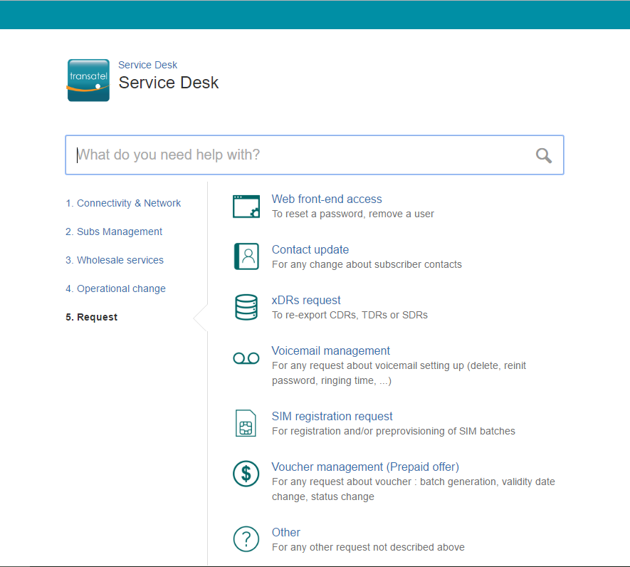

# Change Management (maintenance & releases)

## Description – workflow

A release or System & Network maintenance can be on:

* Provisioning
* Billing
* Transatel Telecom system

A release can be:

* Impacting the service, hence it will be done outside working hours during the night
* Non-impacting the service; hence done during the morning

Notifications are sent 5 days’ prior the change and contain:

* Reference / description of the change
* Intervention time: start date/hour, total duration
* Rollback date/hour
* Services impacted (if any)

Transatel release team will send an email to the MVNO when:

* Change starts
* Change is completed
* Change is aborted, rollback starts (if needed)
* Change is aborted, rollback is completed (if needed)

|  |  |  |
| --- | --- | --- |
| Communication procedure | MVNO contacts | TSL contacts |
| MVNO >TSL notification  MVNO to notify TSL via email with minimum 5 days prior notice.  For emergency change, MVNO shall provide as much notice as reasonably possible |  | To:  NOC@transatel.com  CC:  Servicemanagement.fr@transatel.com |
| TSL > MVNO notification (Release or System & Network Maintenance)  TSL to notify MVNO via email with minimum 5 days prior notice (3 weeks as best-effort).  For emergency change, TSL shall provide as much notice as reasonably possible  TSL notification shall state which MVNOs are impacted. |  | From:  Servicemanagement.fr@transatel.com  CC:  Max.graveline@transatel.com |
| Escalation | Service Manager | Servicemanagement.fr@transatel.com |

## notification template

You can find below a sample of a Transatel e-mail notification:

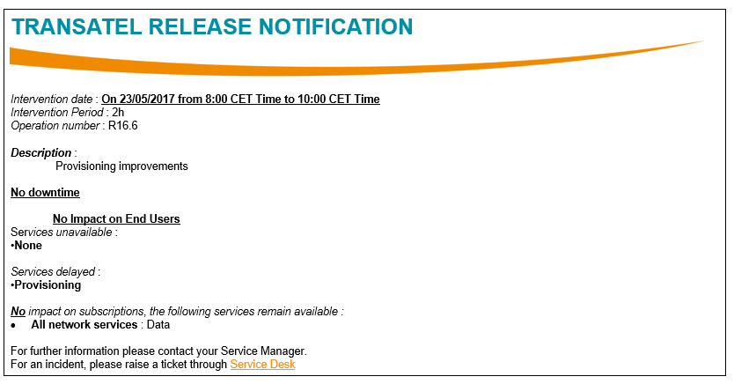

# Change request process

The Change requests process applies to all requests that are deemed out of back office (incl. ad-hoc services) or release/maintenance requests scopes.

Workflow:

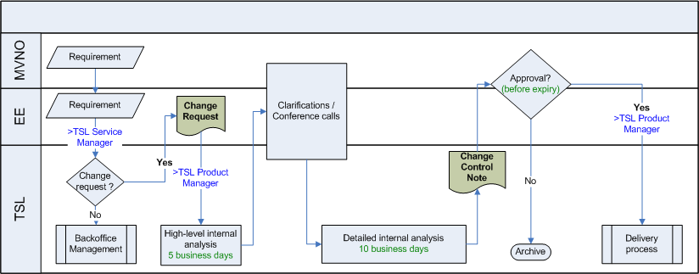

* TSL PPM or TSL SM checks the feasibility, costs and leadtimes for the request and gets back to MVNO

Change Control process (article 7): Unless specific provisions of this Agreement states otherwise, the following change control process (“Change Control Process”) applies to any change in the Service. The Parties shall undertake to review any change of the Services requested by the other Party in good faith. Subject to the MVNO’s prior written agreement, Transatel reserves the right to charge the MVNO a reasonable amount for any review of a change requested by MVNO if a significant amount of effort is required. Transatel will inform MVNO of these Charges and obtain MVNO’s written agreement to the same prior to commencing the review. The Parties will discuss the results of any review, and any changes to the Services and/or the Agreement shall be agreed in writing between the Parties as a result of commercial negotiations and under a supplemental agreement.

# seRvice review meetings & mvnos follow-up

## reporting

Upon Request in order to track down :

* KPI's, SIM ordering, open change requests, utilisation of interconnects, rate changes, etc.
* Forecast / new propositions for awareness (what are MVNOs plans?)

Transatel is defined as leader of this meeting

|  |  |
| --- | --- |
| SRM attendees | |
| MVNO | Transatel |
|  | [servicemanagement.fr@transatel.com](mailto:servicemanagement.fr@transatel.com)  [max.graveline@transatel.com](mailto:max.graveline@transatel.com) |

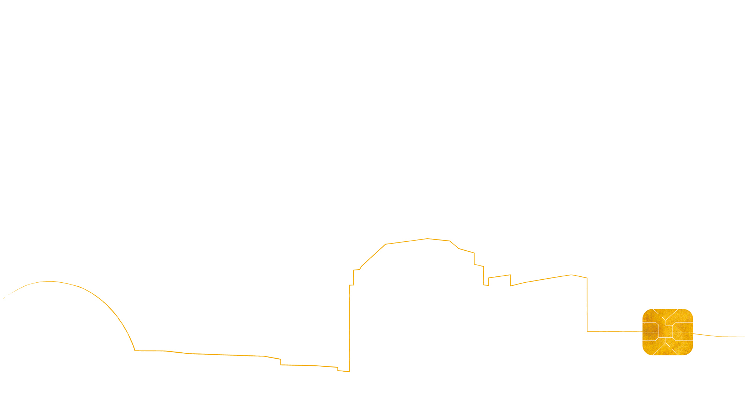



49-51 Quai de Dion Bouton

92800 Puteaux